Infants:  Etsome Terrace,  Somerton, TA11 6LY  Tel: 01458 272537  office@somerton.somerset.sch.uk | 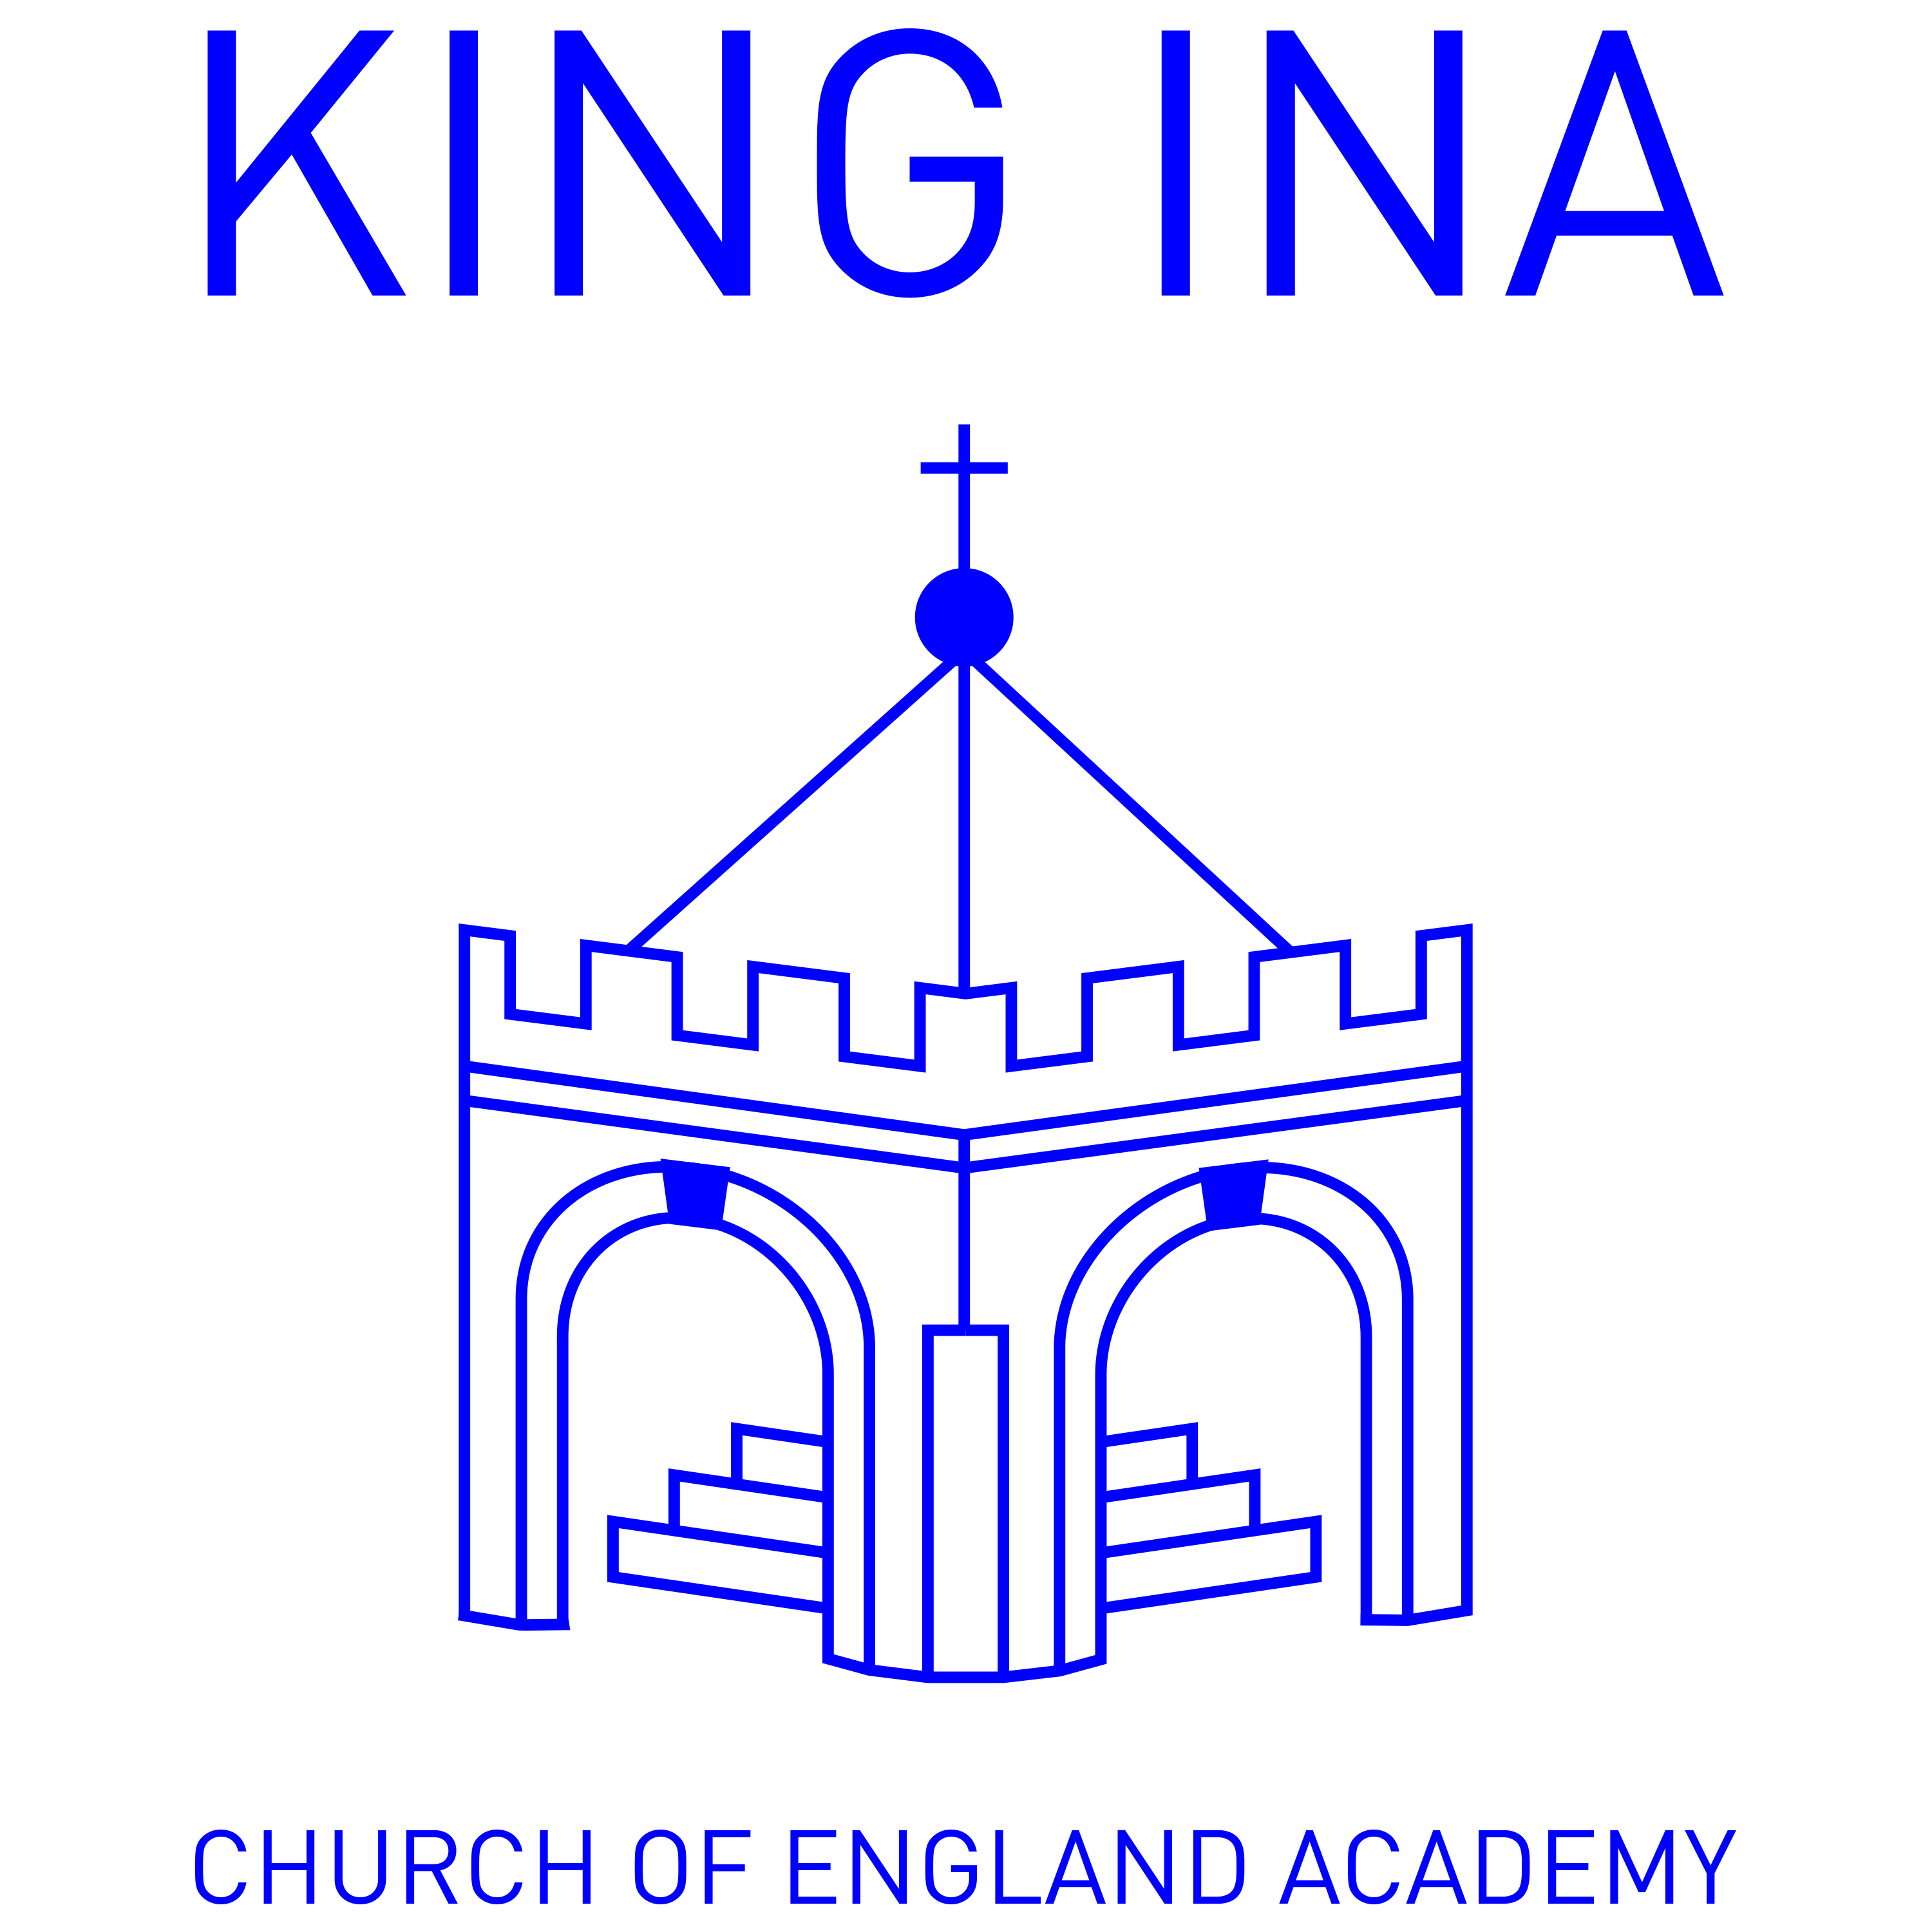 | Juniors:  School Lane, Kirkham St.,  Somerton, TA11 7NL  Tel: 01458 272587  office@monteclefe.somerset.sch.uk
Registered Office: School Lane, Kirkham Street, Somerton, Somerset TA11 7NL

Accessibility Plan

The following extracts are taken directly from the latest SEND Policy and the Medical Conditions Policy.

If you have any specific concerns with regards to accessibility, please contact our SENCo - Mrs Lisa Thompson, to arrange a school visit.

SEND Policy
7. How accessible is the school environment?

We have tried our best to make both school sites as accessible as possible, with some ramped entries. There are changing and disabled toilet facilities on both sites. If your child has any specific needs, you would be welcome to visit the sites to discuss those individual needs. All children have the right to access class trips where it is safe for them to do so. You will have the opportunity to discuss your child’s specific needs prior to any trip or off site visit.

Medical Conditions Policy
- King Ina Academy is an inclusive community that aims to support and welcome children with medical conditions

- King Ina Academy understands that it has a responsibility to make the school welcoming and supportive to children with medical conditions who currently attend and to those who may attend in the future.

- King Ina Academy aims to provide all children with all medical conditions the same opportunities as others at school. We help to ensure they can:

  - Be healthy
  - Stay safe
  - Enjoy and achieve
  - Make a positive contribution
  - Achieve economic well being

- Pupils with medical conditions are encouraged to take control of their condition. Children feel confident in the support they receive from the school to help them do this.

- King Ina Academy aims to include children with medical conditions in all school activities.

- Parents/ carers of pupils with medical conditions feel secure in the care their children receive at King Ina Academy.

- King Ina Academy ensures all staff understand their duty of care to children and young people in the event of an emergency.

- All staff feel confident in knowing what to do in an emergency.

- King Ina Academy understands that certain medical conditions are serious and can be potentially life threatening, particularly if ill managed or misunderstood.

- All staff understand the common medical conditions that affect children at this school. Staff receive training on the impact this can have on pupils when and as appropriate.

- The medical conditions policy is understood and supported by the whole school community.

