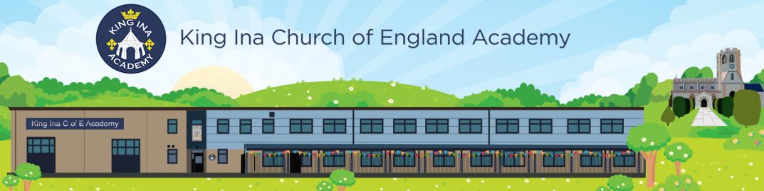

Phonics Progression at King Ina Church of England Academy

Phonics in Owlets at King Ina CofE Academy:
Children in Owlets are exposed to the Phase 1 Units of the Bug Club phonics programme.
Autumn Term 1 | Phase 1 Unit A | A wet welly walk
Autumn Term 2 | Phase 1 Unit B | All sorts of art
Spring Term 1 | Phase 1 Unit C | Nature shapes
Spring Term 2 | Phase 1 Unit D | The missing button
Summer Term 1 | Phase 1 Unit E | From seed to sandwich
Summer Term 2 | Phase 1 Unit F | A day at the beach

Phonics in Reception at King Ina CofE Academy:
By the end of Reception, the aim is for all children to have a secure understanding of Phases 2 to 4 in the Bug Club phonics programme. Children will be expected to be able to segment and blend words within these phases.
Autumn Term 1
Phase 2 | Set 1 | s a t p
 | Set 2 | i n m d
 | Set 3 | g o c k | to
 | Set 4 | ck e u r | the no go

Autumn Term 2
Phase 2 | Set 5 | h b f ff l ll ss | I into
Phase 3 | Set 6 | j v w x | me be
 | Set 7 | y z zz qu | he my by she
 | Set 8 | ch sh th ng | they

Spring Term 1
Phase 3 | Set 9 | ai ee igh oa oo (long) oo (short) | we are
 | Set 10 | ar or ur ow oi | you
 | Review Phase 3 sounds taught so far

Spring Term 2
Phase 3 | Set 11 | ear air ure er | all was give live
 | Review all Phase 3 sounds

Summer Term
Phase 4 | Set 12 | Adjacent consonants  (cvcc, ccvc, ccvcc, cccvc, cccvcc) | said have like so do some come were there little one when out what
 | Consolidate all GPCs learnt so far

Phonics in Year 1 at King Ina CofE Academy:
The aim in Year 1 is to ensure all children have completed Phase 5 and 6 in the Bug Club Phonics Programme.
Autumn Term 1:
Revision of Phase 3 and 4 | Set 12 | Recap of Phase 2 and 3 GPCs  Adjacent consonants  (cvcc, ccvc, ccvcc, cccvc, cccvcc) | said have like so do some come were there little one when out what

Phase 5 | Set 13 | wh ph | oh their people
 | Set 14 | ay a-e eigh ey ei (long a) | Mr Mrs Ms
 | Set 15 | ea e-e ie ey y (long e) | looked called asked

Autumn Term 2:
Phase 5 | Set 16 | ie i-e y i (long i) | water where
 | Set 17 | ow o-e o oe (long o) | who again
 | Set 18 | ew ue u-e (long u) u oul (short oo) | thought through
 | Set 19 | aw au al | work laughed because
 | Revision of Phase 5 taught so far

Spring Term 1:
Phase 5 | Set 20 | ie er ear | Thursday Saturday thirteen thirty
 | Set 21 | ou oy | different any many
 | Set 22 | ere/eer are/ear | eyes friends
 | Set 23 | c k ck ch | two once
 | Revision of Phase 5 taught so far

Spring Term 2:
Phase 5 | Set 24 | c(e) c(i) c(y) se | great clothes
 | Set 25 | g(e) g(i) dge | it’s I’m I’ll I’ve
 | Set 26 | le mb kn gn wr | don’t can’t didn’t
 | Set 27 | tch sh a zh o | first second third
 | Revision of Phase 5 taught so far

Summer Term 1:
Phase 6 | Set 28 | suffix morphemes  ing ed | clearing gleaming rained mailed
 | Set 29 | plural morphemes  s es | men mice feet teeth sheep
 | Set 30 | prefix morphemes  re un  prefix + root + suffix | vowel consonant prefix suffix syllable

Summer Term 2:
Consolidation of Phase 5 and 6 | Consolidation of Phase 5 and Phase 6

Phonics in Year 2 at King Ina CofE Academy:
Autumn Term 1:
Revision of Phase 5 and 6 | Revision of Phase 5 and 6 using Bug Club Phonics

From Autumn Term 2, Year 2 children will move on to following the Westover Green spelling programme in line with the rest of the school.

