
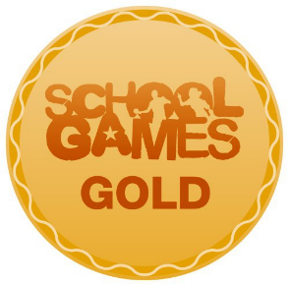
KING INA’S
SPORTY NEWS

SUMMER TERM SPORTS CLUBS

Tuesday
Club: Fun on the Field Club
Time: 8.00 – 8.40am
Club: Year 3/4 Cricket
Time: Lunchtime
Club: Year 5/6 Netball
Time: Lunchtime

Wednesday
Club: Athletics
Time: 3.15 – 4.14pm

Thursday
Club: Multi-skills (All years)
Time: 8.00 – 8.40am
Club: Year 5/6 Boys’ Cricket
Time: Lunchtime
Club: Year 3/4 Netball
Time: Lunchtime

Friday
Club: Year 5/6 Girls’ Cricket
Time: Lunchtime

Welcome to King Ina’s
Spring Sports Newsletter

The weather has finally started getting better and we have been enjoying some of our Summer sports.

Many children have also been taking part in activities outside of school at various local clubs and have been interviewed by our sports captains.

Year 3/4 CLP Tag Rugby Tournament

The year 3/4 tag rugby tournament finally went ahead after two cancellations due to bad weather. Our two teams thoroughly enjoyed themselves and one team managed to get to the semi-finals.

Inter Area Cross Country

Well done to twelve of our cross country runners who were chosen to represent Huish Area at the Inter Area Championships at Yeovil. All did well, with Poppy getting a bronze medal in her race & the year 3/4 girls’ team also getting a bronze.

Phoebie’s Sports Profile

Year: 6

Class: Red Kites

Club: Griffin Trampoline Club

What does she enjoy about it?:

“It’s great fun to flip in the air!”



Our House Sports Captains
Romans
Celts
Saxons
Vikings







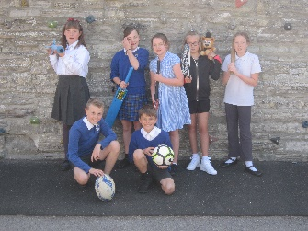
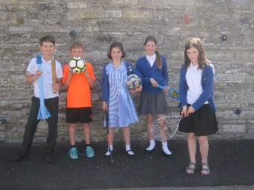
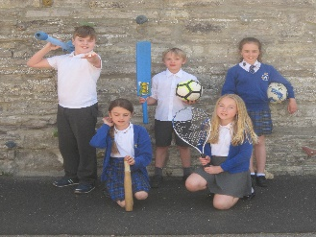
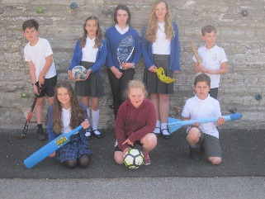

Year 3/4 High Fives Netball Festival

Our year 3/4 netballers had their first taste of competitive netball at Huish. They improved with each game and, if they keep practising with Mrs Bright, will get even better!

Fun on the Field Club

Every Tuesday morning, some of our children head to the school field at 8am to do lots of fun activities to wake them up and get them ready for the school day. Why don’t you join them?
Cricket Tournament
After beautiful sunshine for several days, the rain came for our CLP Cricket Tournament at Curry Rivel Cricket Club. However our two teams, King Ina Lions & King Ina Lionesses, were undeterred and played some super cricket, with the Lionesses managing to get to the semi-final.








Girls’ Cricket Coaching Day

Some of our girls enjoyed a cricket coaching day at Huish & Langport Cricket Club led by Sophie Luff, Somerset Women’s cricket captain and Western Storm player. The girls learnt lots and put their skills into practice in the afternoon, playing some matches against each other.

Quad Kids Athletics

Lots of super jumping, throwing and running from our Year 5/6 Quad Kids Athletics team, who competed at Huish Episcopi.

Chloe’s Sports Profile

Year: 4
Class: Peregrines
Club: Wildcats Girls Football Club

What does she enjoy about it?: ‘’I like playing football and making new friends. ‘’

Charlotte’s Sports Profile

Year: 4

Class: Kestrels

Club: Orchard Gymnastics

What does she enjoy about it?: She enjoys having fun with her friends.

