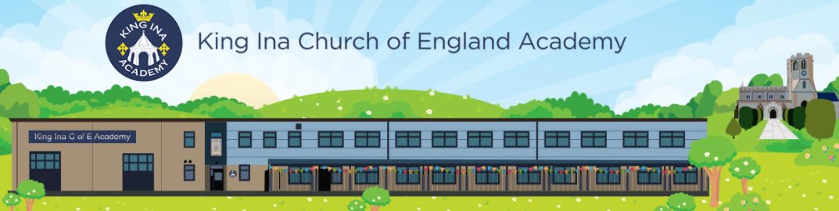
Phonics at King Ina Church of England Academy
Intent:
Reading is a crucial life skill and at King Ina Church of England Academy, we intend that children become fluent readers through phonics as quickly as possible. We prioritise the teaching of systematic, synthetic phonics from the beginning of Reception until they are competent Phase 5 readers. Children will be able to more easily access the wider curriculum from a young age and develop a lifelong love of reading across a variety of genres. Due to our rigorous phonics teaching programme, alongside reading, children are also taught to spell words phonetically and make sensible grapheme choices. Those teaching phonics are provided with training opportunities to develop their practice, so that we have a team of experts leading its delivery.
Implement:
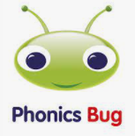
At King Ina Academy we use Pearson's Bug Club programme to support the teaching of phonics and follow the Bug Club structure of teaching letter sounds.
Daily phonics lessons:
- Each phonics lesson includes the following elements:
- Revisit and review – practise previously learnt graphemes
- Teach – introduce and teach a new grapheme
- Practise – practise blending and segmenting with the new GPC (Grapheme Phoneme Correspondence)
- Apply – read or write captions/sentences with the new grapheme
- From reception, we quickly build up to teach one whole class 30-minute phonics session per day
- Teaching of Phonics in reception starts in their first full-time week in September (week 3)
- We follow the Pearson’s Bug Club programme with the following expectations:
  - Children in Owlets are exposed to the Phase 1 units in the Bug Club phonics programme.
  - Children in Reception are taught to blend and segment words using Phase 2 and 3 GPCs, and words with adjacent consonants (Phase 4) with fluency and accuracy.
  - At the beginning of Key Stage One, children review their previous phonics learning to aid retention and are taught to blend and segment words using Phase 5 GPCs with fluency and accuracy.
  - At the beginning of Year 2, children review their previous Phase 5 and 6 phonics learning to aid retention using the Phonics Bug programme. Then, children move onto the school’s spelling programme to ensure full coverage of the National Curriculum Year 2 spelling objectives. (Westover Green)
Home reading
Children have phonically decodable reading books from the Bug Club reading scheme. These books are matched to their phonics knowledge based on assessment data. The children are encouraged to read regularly at home to ensure fluency in reading is developed. Books are chosen and changed regularly, ensuring that children have had the opportunity to read their phonics book 3 times. The first read is to encourage familiarity with the text. The 2nd read is to aid fluency. The 3rd read is to support comprehension.
So that parents and carers are able to competently support their child’s reading at home, parents are invited to attend a Phonics Workshop in the first 3 weeks of their child’s schooling. The information from the Phonics Workshops are also provided in a PowerPoint on the school website. (This has been invaluable during the Covid 19 pandemic.)

Assessment
Assessment is used to monitor progress and to identify any child needing additional support.
- Assessment for learning is used daily within class to identify children needing support and to inform planning.

- Summative assessment is used every half term to assess progress, to identify gaps in learning that need to be addressed and any children needing additional support. In addition to this, summative assessment takes place at the start of Year 1 and 2 to establish children have retained their phonics learning. Where children do need support to retain their previous learning, they are given opportunities to catch up through precision teaching and phonics interventions. Readers who are at the bottom 20% of their cohort have extra opportunities to read in school throughout the week. When children, through summative assessment, show that they can competently read Phase 5 sounds within words, they join the Accelerated Reader programme, which extends through to the end of Key Stage 2.

- Statutory assessment - children in Year 1 sit the Phonics Screening Check in the summer term. Any child not passing the check is supported to make accelerated progress, aiming for success in Year 2.

Professional Development
All teaching staff from Reception to Year 6 are provided with training in phonics delivery, focussing on the Bug Club programme, articulation of phonemes and key phonics vocabulary. New members of staff joining our school team are provided with this soon after arrival.
Impact

At King Ina Church of England Academy, our aim is for all children to be competent readers by the end of Key Stage One, who have a thirst for reading. Across the school, children can recommend books to their peers, enjoy a range of genres, and participate in discussions about text they read.
At King Ina Church of England Academy, we believe that reading is the key to all learning and so the impact of our phonics teaching goes beyond just learning to read, equally enabling children to access the entire curriculum and preparing them to be confident citizens, as they grow.

