Irresistible Outdoors!
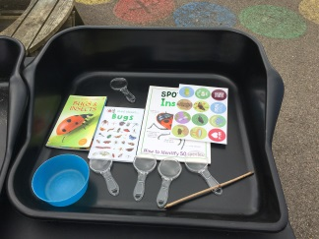 | 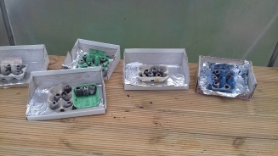 | 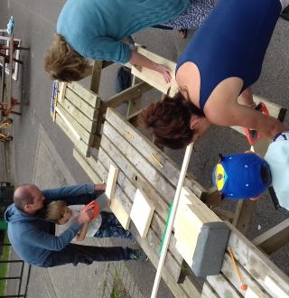 | 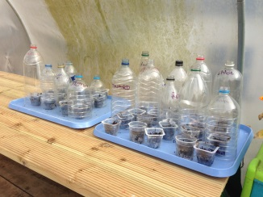
Outdoor adventures including gardening, grow-your-own, wildlife and well-being activities for ages 4-11 to encourage and support learning and exploration.
Simple, relaxed, family-focussed fun in the garden of Baltonsborough CEVC School, Ham Street, Baltonsborough, BA6 8PX.
All children must have an accompanying adult. £5 per child.
10am to 12noon Saturday: 22 June, 27 July, 24 August, 28 September and 27 October 2019.
Max attendance 10 children so please book in advance: coraliescottagegardens@gmail.com

