HUISH & LANGPORT CRICKET CLUB JUNIOR MEMBERSHIP FORM 2018
Junior membership in 2018 is £30 for the first child plus £20 for one additional sibling with any other siblings £10 each.
Includes all coaching* and junior match fees.**
All membership fees to be paid by May 1st please.
Please note:
*You will be specifically advised of any exceptions i.e. juniors invited to attend senior indoor nets.
**Should your child be selected for and subsequently play in a senior team (1st, 2nd, 3rd XI or the Sunday side) they will then be subject to pay an additional match fee of £3-00 per game. In this instance from 2010 new E.C.B regulations require that you must provide additional consent to your child playing in such senior matches by way of an E.C.B. standard letter available from Tracy Robinson [Welfare Office].

Players personal Details. [Please complete the form in full]
Junior members name:
Gender: (Please circle as appropriate) Male Female
Date of birth:
Age last birthday:
School year:
School:

Name/s of parents or guardians:
Parent or guardian occupation/s:
[You may have skills or expertise that can help the club]

Home address:
Postcode:
Home telephone number:
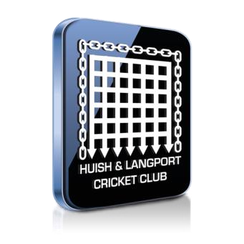
Parent or guardians mobile telephone numbers: Parent or Guardians contact e-mail:

Huish & Langport Cricket Club operates a code of conduct] for all junior members. Each member is required to behave in accordance with that code or face disciplinary action. A copy of the code of conduct is available to view on the clubs notice board or can be requested from our welfare officer. Junior players must sign below to confirm that they will abide by the clubs rules & code of conduct.

Junior member’s signature: Date:

Emergency Contact Details and Medical Information.
In case of emergency please contact:
Emergency contact numbers:

Medical Information:
Please detail below any important medical information that our coaches or team managers should be aware of (e.g. epilepsy, asthma, diabetes, etc.)
Do you consider that your child has a disability? (Circle as appropriate) Yes No
If yes what is the nature of their disability. Please circle as appropriate. Please let us know if we can further assist your child in any way.

Visual impairment Hearing impairment Physical disability
Learning disability Multiple disabilities Other (please specify)
By returning this form I agree to my child taking part in the activities of the club this includes being photographed during matches or videoed for coaching purposes. I understand that in the event of illness or injury all reasonable steps will be taken to contact me and to deal with the injury or illness appropriately.
Signature f parent or guardian : Date:

