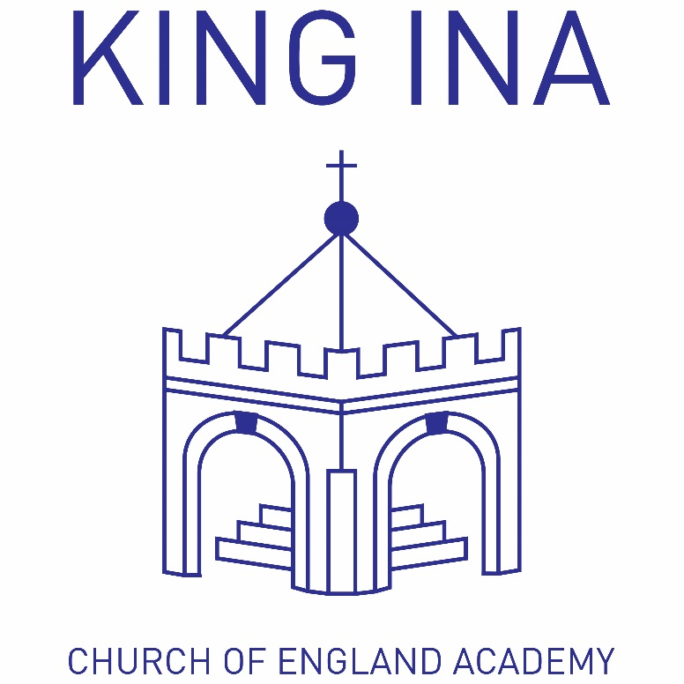
‘Developing happy, hardworking learners who can achieve their full potential in a secure Christian environment.’

King Ina C of E Academy

Special Educational Needs & Disabilities Policy

(SEND)

Revised September 2017

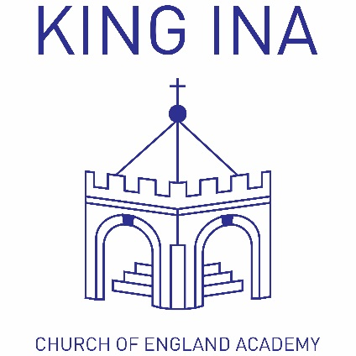
Juniors:
School Lane, Kirkham St.,
Somerton, TA11 7NL

Tel: 01458 272587
office@monteclefe.somerset.sch.uk

Infants:
Etsome Terrace,
Somerton, TA11 6LY

Tel: 01458 272537
office@somerton.somerset.sch.uk

Date: | September 2017 | Review Date: | September 2018

Special Needs Co-ordinator (SENCO) | Governor for SEN
Mrs Lisa Thompson | Mrs Ann Faulkner

We believe that… 'Children have special educational needs if they have a learning difficulty, which requires additional or significantly different provision than their peers’.

Children have a learning difficulty if they:

- have a significantly greater difficulty in learning than the majority of children of the same age, or

- have a disability which prevents or hinders them from making use of educational facilities of a kind generally provided for children of the same age in schools within the area of the local education authority, or

- are under compulsory school age and fall within the definition at (a) or (b) above or would do so if special educational provision was not made for them.

Special educational provision means:

- for children of two or over, educational provision which is additional to, or otherwise different from, the educational provision made generally for children of their age in schools maintained by the LEA, other than special schools, in the area.

- for children under two, educational provision of any kind.' (Education Act 1996)

Statement of Intent
It is the aim of our school to provide every child with the best education possible. Our objective in setting out the school's SEND policy is to make everyone aware that we want all pupils to benefit as fully as possible from the education provided within the school.

We cater for pupils who experience difficulties with:

- Communication and Interaction (CI)
- Cognition and Learning (CL)
- Social, Emotional and Mental Health issues (SEMH)
- Sensory and/or Physical and Medical conditions

The school has full provision for pupils who are disabled, and we respond to all needs on an individual basis.

Aims and Objectives

We aim:

- To identify pupils with SEN as early as possible and ensure that their needs are met.
- To have effective systems in place whereby teachers can ensure that the SEND team are aware of such pupils.
- To provide all our children with a broad and balanced curriculum that is differentiated to the needs and ability of the individual.
- To be sympathetic to each child's needs by providing a strong partnership between children, parents, governors, LEA and outside agencies.
- To ensure all pupils make effective progress and realise their full potential.
- To ensure all pupils take a full and active part in school life.

Admissions

We will:

- treat all applications equally and we will not discriminate against pupils with special educational needs.
- admit children with special educational needs but who do not have a Provision Map or Education & Health Care Plan.
- not refuse admission to children with special educational needs because we feel that we will be unable to provide the necessary support.

Complaints Procedure
Parents who have a grievance or complaint about any aspect of the additional support or care that their child receives are encouraged to ask for a mutually convenient meeting with the school in order to resolve the issue.

The Local Education Authority have a legal requirement to have 'arrangements with a view to avoiding or resolving disagreements between parents and certain schools about the special educational provision made for their child.' (SEN Code of Practice)

Curriculum

The school aims to provide for all SEN pupils:

- a broad and balanced curriculum
- a curriculum which is differentiated to each child’s specific needs
- a range of teaching strategies to meet children’s needs
- Individual Provision Maps, with a specific focus and outcome, based on the pupil's needs.

Range of Provision

The school aims to provide support for our children with SEN as effectively as possible. This might include:

- in-class support, individually or in small groups with specialist teachers and/or Teaching Assistants (TAs)
- withdrawal support, individually or in small groups with specialist teachers and/or TAs
- Specialist professional support from external agencies, such as Speech & Language, Occupational Therapists and Educational Psychlogists.

As a school we are also able to draw on the expertise and knowledge of our colleagues at Learning Support Services (LSS). LSS work to support children in Somerset schools to ensure that all children can access school fully.

Roles and Responsibilities

Special Educational Needs Coordinator (SENCo) | - To work with the Headteacher to oversee the day to day provision for pupils with  special educational needs within the school.  - To report annually to the Governors and LSS about the schools SEN provision.  - To inform parents when SEN provision has been made for their child.
The Governing Body | - To ensure that provision of SEN is of a high standard.  - To have regard to the Code of Practice when undertaking its responsibilities.  - To have in place a designated SEN Governor who will make sure that children with known special educational needs, are having those needs met as fully as possible.  - To have in place a strategy to monitor the school's SEN policy.
The Headteacher | - To ensure that the daily management of SEN provision is effective.  - To work closely with the SENCO and the teaching and support staff.  - To keep the Governing Body informed of all matters relating to its responsibilities for the provision of SEN.
Class Teachers | - Class Teachers have an overall responsibility for the care, education and welfare of all children in their class, including (and perhaps especially) children with SEN.  - To be aware of the school's Graduated Response for the identification and assessment of pupils with SEN and the provision it makes for them.  - To deliver Quality First Teaching for all children, and assess the impact of Wave 1 interventions for children with possible SEN.  - To liaise closely with the SENCo and/or SEND Coordinators to develop Provision Maps with specific targeted outcomes.  - To regularly speak with parents regarding their child’s progress and/or needs.  - To notify parents when the school feels that their child has special educational needs and is going to receive additional support.
Parents | - To work closely with the school in order to develop a partnership that will support SEN pupils.

Identification and Assessment

Early Identification - At King Ina Academy (KIA) we feel it is vital that pupils with SEN are identified at an early stage. Every teacher in this school is responsible for identifying any pupils with SEN within their class. We will inform parents at the earliest opportunity of the school's concerns and that the appropriate SEN provision has been made for their child.

Assessment - It is essential that all teachers in the school have the necessary observational skills to identify pupils with SEN at an early stage. Teacher observations, records from feeder schools and information from parents provide an overall picture of a child's problems and subsequent needs. We also have a structured Graduated Response which all teachers use.

Once pupils have been identified as having any form of difficulty in accessing the curriculum, the school will work through the Somerset Core Standards for All Children and Young People (4 to 16), and implement a programme of Graduated Response. There are three levels of support within the Graduated Response:
Graduated Response to Pupils’ Needs

- Universal – High Quality Teaching for ALL children and Young People
- SEN Support – Additional Targeted Support for SOME Children and Young People
- High Needs – Support for complex and long term difficulties for A FEW Children and Young People

King Ina Academy works in conjunction with the local Community Learning Partnership (CLP) to ensure that children across our locality have equal access to the best education possible that fully meets each child’s individual needs.

This is in line with Somerset’s Core Standards for SEND, which ensures:

- Early accurate identification
- Positive experience
- Partnership working
- Effective transitions at key points
- Inclusive quality local education

At King Ina Academy we also consider more recent Government documents including; Removing Barriers to Achievement (DfES 2004); Every Child Matters (2003); Special Educational Needs and Disability Act (2001) and the National Standards Framework (2004).

UNIVERSAL Provision for All. The most recent Code of Practice for SEN clearly states that ‘all teachers are teachers of children with Special Educational Needs’, and this is reiterated in the Somerset Core Standards – SEND is everyone’s business. Most pupils make progress through the normal differentiated curriculum offered to all pupils. This includes national literacy, numeracy and social inclusion initiatives to raise achievements through quality first teaching.

King Ina Academy has a Provision Map that covers the educational and social needs of our children from 2 year olds through to 11 year olds. This gives an overview of what may be provided, as well as strategies and resources that can be used for areas that have been identified as needing extra support.

If a child continues to cause concern and progress is unsatisfactory then the class teacher will make a referral to the SENCo.

SEN Support is additional targeted support. The class teacher identifies individual pupils with specific needs and liaises with the SENCo to make provision to address these needs. In Somerset, as noted previously, Learning Support Services are available to advise and guide schools in building capacity and ensuring that individual needs are met. SEN Support Intervention can be triggered through concern that despite receiving differentiated teaching, pupils:

- make little or no progress
- show difficulty developing literacy or numeracy skills
- present persistent emotional and behavioural difficulties
- have sensory or physical problems, which continue despite the use of specialist equipment
- have communication and/or interaction problems, which continue despite curriculum differentiation
- are working at levels well below that expected of a child of a similar age
- still face difficulties in developing literacy and numeracy skills
- have communication or interaction problems which prevent the development of social relationships

The SENCo will consider an appropriate approach such as:

- providing different materials or equipment
- using extra staff to work closely with the pupil
- more effective strategies via staff development or training
- group support
- devising interventions and monitoring their effectiveness by providing extra adult time
- LEA support for advice on strategies and equipment or staff training

An Individual Provision Map (IPM) will:

- record strategies for pupil progress by concentrating on a small number of individual targets that meet the pupil's needs.
- be re-assessed on a half-term/termly basis, depending on the nature of the intervention.
- record the extent to which targets have been met
- set new targets, outline new strategies and the provision to be made

If, at an IPM review it is considered the pupil has not progressed then the SENCo will consider whether further support is required. These children will then be discussed at a Consultation Meeting with representatives from the Learning Support Services and the Education Psychology Team. This will result in further investigations, or specialist support being given.

High Needs Support for complex and long-term difficulties, is available for the small number of children who require it. A child in need of High Needs Support will ALWAYS have an Individual Provision Map, and often have a separate Care Plan detailing their specific needs, alongside annual reviews of their care. External agencies will also be involved to support staff and ensure that these children are having all their needs met appropriately.

The Somerset LEA response to the SEN Code of Practice (2014) identifies that High Needs Support is for individual pupils who have severe and complex needs. At King Ina Academy we are working towards developing an Education & Health Care Plan (EHC Plan) for all children considered to have Wave 3 needs in a number of health/educational areas. The EHC Plan is then able to be used as a foundation if the child still remains a cause for concern and the child’s parents, teacher and LEA feel that the child requires provision beyond what the school can offer; or the child’s needs require a highly coordinated multi agency provision to support their mainstream placement.
An Education & Health Care Plan will:

- outline details of the LEA's assessment of the child's special educational needs
- state the special educational provision which will be made to meet those needs
- identify the type of school which the LEA believes would be appropriate to make such provision
- identify either the school which it considers to be suitable or the school for which the parents have expressed a preference
- state where the special provision is to be provided otherwise than at school.

Every child with an EHC Plan at King Ina Academy, will also have an Annual Review.

The Annual Review will:

- assess the progress of the pupil in relation to their targets
- review the provision made for the pupil
- consider ending, continuing or amending the existing provision and/or targets
- set new targets for the following year

A transitional review is when pupils leave Primary education, and move to Secondary Education, it enables the receiving school to plan appropriate provision for the child. At King Ina Academy we have excellent links with our main secondary school – Huish Episcopi Academy.

Partnerships

- We believe that a close partnership with parents will enable children to progress. Parents have a key role to play in the partnership between home and school as they have an exclusive overview of the provision needed for the child.
- Pupils with SEN will benefit from the school's close working relationship with the numerous external support agencies, which offer advice and support.
- We feel that the provision for SEN in this school will benefit from the close links we have with other schools by the sharing of good practice and in making the transition between phases as smooth as possible for the pupils.

Evaluation and Review

The effectiveness of the SEN provision provided by the school will be reviewed annually by the Governing Body and reported to parents in the Annual Governors Report; however the school SENCo and the school SEN Governor meet every half-term to monitor and review effective practice constantly.

A review of the SEN policy document is undertaken every year and as a working document is kept under constant review.

Headteacher: | David Norton | Date: | September 2017
Chair of Governing Body: | David Speed | Date: | September 2017

