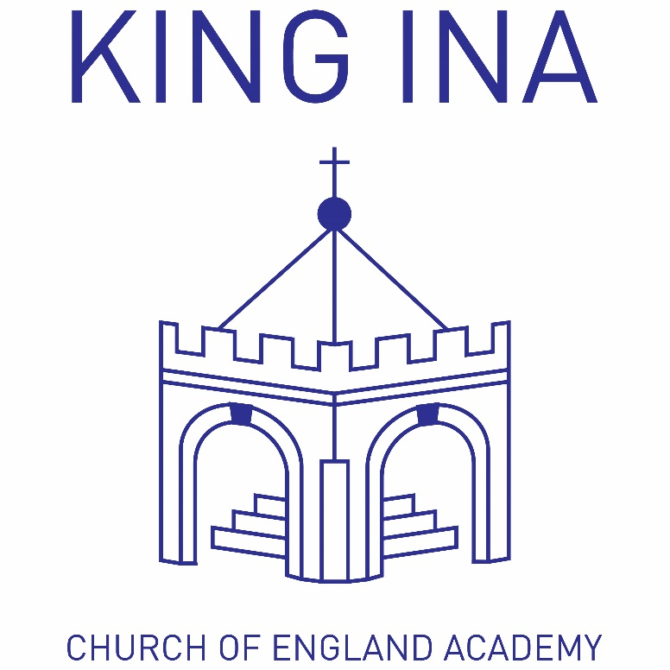
‘Developing happy, hardworking learners who can achieve their full potential in a secure Christian environment.’

King Ina C of E Academy

Medical Conditions Policy

Revised September 2017

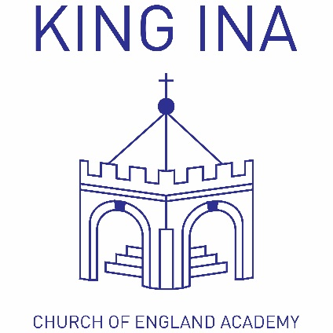
Juniors:
School Lane, Kirkham St.,
Somerton, TA11 7NL

Tel: 01458 272587
office@monteclefe.somerset.sch.uk

Infants:
Etsome Terrace,
Somerton, TA11 6LY

Tel: 01458 272537
office@somerton.somerset.sch.uk

Date: | September 2017 | Review Date: | September 2018

Special Needs Co-ordinator (SENCO) | Governor for SEN
Mrs Lisa Thompson | Mrs Ann Faulkner

Rationale:
- King Ina Academy is an inclusive community that aims to support and welcome children with medical conditions
- King Ina Academy aims to provide all children with all medical conditions the same opportunities as others at school

Guidelines:

- King Ina Academy is an inclusive community that aims to support and welcome children with medical conditions

- King Ina Academy understands that it has a responsibility to make the school welcoming and supportive to children with medical conditions who currently attend and to those who may attend in the future.

- King Ina Academy aims to provide all children with all medical conditions the same opportunities as others at school. We help to ensure they can:

  - Be healthy
  - Stay safe
  - Enjoy and achieve
  - Make a positive contribution
  - Achieve economic well being

- Pupils with medical conditions are encouraged to take control of their condition. Children feel confident in the support they receive from the school to help them do this.

- King Ina Academy aims to include children with medical conditions in all school activities.

- Parents/ carers of pupils with medical conditions feel secure in the care their children receive at King Ina Academy.

- King Ina Academy ensures all staff understand their duty of care to children and young people in the event of an emergency.

- All staff feel confident in knowing what to do in an emergency.

- King Ina Academy understands that certain medical conditions are serious and can be potentially life threatening, particularly if ill managed or misunderstood.

- All staff understand the common medical conditions that affect children at this school. Staff receive training on the impact this can have on pupils when and as appropriate.

- The medical conditions policy is understood and supported by the whole school community.

- The medical conditions policy is supported by a clear communication plan for staff, parents/ carers and other key stakeholders to ensure its full implementation

- Children are informed about the medical conditions policy:
  - Through the school council
  - In PSHE lessons

- the medical conditions policy is made available to parents/ carers:
  - by including the policy statement on the school website, in the school’s prospectus, staff handbook and welcome booklets.

- School staff are informed about the medical conditions policy:
  - Through information provided in their staff information booklet
  - At any medical conditions training
  - All supply and temporary staff are informed of the policy and their responsibilities as appropriate

- All staff understand and are trained in what to do in an emergency for the most common serious medical conditions at this school as and when appropriate.

- All staff at King Ina Academy are aware of the most common serious medical conditions at this school.

- Staff at King Ina Academy understand their duty of care to children in the event of an emergency. In an emergency situation school staff are required under common law duty of care to act like any reasonably prudent parent. This may include administering medication.

- All staff who work with groups of children at this school receive training and know what to do an emergency for the children in their care with medical conditions.

- Training is refreshed for all staff as and when appropriate

- King Ina Academy uses Healthcare/Medical Plans to inform the appropriate staff (including supply teachers and support staff) of pupils in their care who may need emergency help.

- King Ina Academy has procedures in place so that a copy of a child’s healthcare/medical plan is sent to the hospital with the child. On occasions when this is not possible, the form is sent (or the information on it is communicated) to the hospital as soon as possible.

- All staff understand and are trained in the school’s general emergency procedures.

- All staff know what action to take in the event of a medical emergency. This includes:
  - How to contact emergency services and what information to give
  - Who to contact within the school

- Training is refreshed for all staff as and when appropriate

- Action to take in a general medical emergency is displayed in prominent locations for staff.

- If a child needs to be taken to hospital, a member of staff will always accompany them and will stay with them until a parent arrives. The school tries to ensure that the staff member will be one the child knows.

- The school has clear guidance on the administration of medication at school. Staff may only administer prescription medicines. Non-prescription medicines should NOT be brought into school.

Administration – emergency medication

- All children at this school with medical conditions have easy access to their emergency medication

- All children are encouraged to carry and administer their own emergency medication, once their parents/ carers and health specialist determine they are able to start taking responsibility for their condition. All pupils carry their emergency medication with them at all times, except if they are controlled drugs as defined in the Misuse of Drugs Act 1971. This is also the arrangement on any off site or residential visits.

- Children who do not carry and administer their own emergency medication know where their medication is stored and how to access it.

- Children who do not carry and administer their own emergency medication understand the arrangements for a member of staff (and the reserve member of staff) to assist in helping them take their medication safely.

Administration – general medication

- All use of medication defined as a controlled drug, even if the child can administer the medication themselves, is done under the supervision of a member of staff at this school.

- This school understands the importance of medication being taken as prescribed.

- All staff are aware that there is no legal or contractual duty for any member of staff to administer medication or supervise a child taking medication unless they have been specifically contracted to do so.

- There are several members of staff at this school with first aid training who can support children to take medication.

- Many other members of staff are happy to take on the voluntary role of administering medication. For medication where no specific training is necessary, any member of staff may administer prescribed medication to children under the age of 16, but only with the written consent of the child’s parent/ carer.

- Training is given to all staff members who agree to administer medication to children, where specific training is needed. The local authority provides full indemnity.

- All school staff have been informed through training that they are required, under common law duty of care, to act like any reasonably prudent parent in an emergency situation. This may include taking action such as administering medication.

- In some circumstance medication is only administered by an adult of the same gender as the pupil, and preferably witnessed by a second adult.

- Parents/ carers at King Ina Academy understand that if their child’s medication changes or is discontinued, or the dose or administration method changes that they should notify school immediately.

- If a child at King Ina Academy needs supervision or access to medication during home/ school transport organised by the LA, properly trained escorts are provided.

- All staff attending off site visits are aware of any child with medical conditions on a visit. They receive information about the type of condition, what to do in an emergency and any other additional support necessary, including any additional medication or equipment needed.

- If a trained member of staff, who is usually responsible for administering medication is not available alternative arrangements are made to provide the service. This is always addressed in the risk assessment for off-site activities.

- If a child misuses medication, either their own, or another childs, their parents/ carers are informed as soon as possible. These children are subject to the school’s usual disciplinary procedures.

- King Ina Academy has clear guidance on the storage of medication at school

Safe storage – emergency medication

- Emergency medication is readily available to children who require it at all times during the school day or at off-site activities. If the emergency medication is a controlled drug and needs to be locked up, the keys are readily available and not held personally by members of staff.

- At King Ina Academy most children either carry their emergency medication on them at all times or it is placed in the class medicines box within the medical room.

- Children at King Ina Academy are reminded to carry their emergency medication with them when they leave the classroom

- Children, whose healthcare professionals and parents and carer advise the school that their child is not yet able or old enough to self-manage and carry their own emergency medication, know exactly where to access their emergency medication

Safe storage – non emergency medication

- All non-emergency medication is kept in a secure place. Children with medical conditions know where their medication is stored and how to access it.

- Staff ensure that medication is only accessible to those for whom it is prescribed

Safe storage – general medication

- Office Managers ensure the correct storage of medication outside of the classrooms

- All controlled drugs are kept in a locked cupboard and only named staff have access, even if children normally administer the medication themselves.

- Expiry dates for all medication stored at school is checked at the end of each term.

- The identified member of staff, along with the parents/ carers of children with medical conditions, ensure that all emergency and non-emergency medication brought in to school is clearly labelled with the child’s name, the name and dose of the medication and the frequency of dose. This includes all medication that children carry themselves.

- All medication is supplied and stored, wherever possible, in its original containers. All medication is labelled with the child’s name, the name of the medication, expiry date and the prescriber’s instructions for administration, including dose and frequency.

- Medication is stored in accordance with instructions, paying particular note to temperature.

- Some medication may need to be refrigerated. All refrigerated medication is stored in an airtight container and is clearly labelled. The refrigerator in the staff room is used for this purpose.

- All medication is sent home with children at the end of the school year.

- It is the parents/ carers responsibility to ensure new and in date medication comes into school on the first day of the new academic year.

Safe disposal

- Parents/ carers are asked to collect out of date medication

- If parents do not pick up out of date medication, or at the end of the school year, medication is taken to a local pharmacy for safe disposal.

- The SEND Team are responsible for checking the dates of medication stored in the medical room and will arrange for the class teacher to return it to the parent/carer to arrange disposal of any that have expired. This check should be done at the end of each term.

- Sharps boxes are used for the disposal of needles when needed. Parents/ carers obtain sharps boxes from the child’s GP or paediatrician on prescription. All sharps boxes in this school are stored in a locked cupboard unless alternative safe and secure arrangements are put in place on a case by case basis.

- If a sharps box is needed off site or on a residential visit, a named member of staff is responsible for its safe storage and return to a local pharmacy or to school or to the parents/ carers.

- Collection and disposal of sharps boxes is arranged with the LA’s environmental service.

- King Ina Academy has clear guidance about record keeping

Data collection forms

Parents and carers are asked if their children have any health conditions or health issues on an annual basis. Parents/ carers of new pupils starting at other times of the school year are also asked to provide this information on data collection plans.

Healthcare/Medical Plans

- King Ina Academy uses healthcare/medical plans to record important details about individual children’s medical needs at school, their triggers, signs, symptoms, medication and other treatments. Further documentation can be attached to this plan if required.

- Healthcare plans are issued for completion by parents/ carers of children with long term medical conditions at

  - The beginning of the school year
  - On enrolment
  - When a diagnosis is first communicated to the school

- If a child has a short term medical condition that requires medication during school hours, a medication form should be completed by the child’s parents/ carers.

- Where appropriate it is recommended that the parents/ carers, health care professional and the child should complete the healthcare plan together, before returning to school. A member of school staff can also be present in cases of complex healthcare or educational needs.

- Healthcare plans are held centrally, copies are also held by class teachers. All members of staff who work with groups of children have access to the Healthcare plans of children in their care.

- Parents/ carers are reminded to update their child’s healthcare plan if their child has a medical emergency or if there have been changes to their symptoms (getting better or worse), or their medication and treatments change.

- Staff use opportunities such as teacher-parent consultations and home-school diaries to check that information held by the school on a child’s condition is accurate and up to date.

- King Ina Academy ensures that all staff protect pupil confidentiality

- King Ina Academy seeks permission from parents/ carers to allow the Healthcare plans to be sent ahead to emergency care staff, should an emergency happen during school hours or at a school activity outside of the normal school day. This permission is included on the Healthcare plan.

- This school seeks permission from the child and parents/ carers before sharing any medical information with any other party.

Use of Healthcare/Medical plans

Healthcare plans are used at Glynwood to:

- Inform appropriate staff and supply teachers about the individual needs of a child with a medical condition in their care.
- Remind children with medical conditions to take their medication when they need to and, if appropriate, remind them to keep their emergency medication with them at all times.
- Identify common or individual triggers for children with medical conditions at school that bring on symptoms and can cause emergencies, and subsequently reduce the impact of common triggers.
- Ensure that all medication stored in school is within expiry date
- Ensure the school is provide timely and accurate information regarding the child’s condition to emergency services if required

Consent to administer medicines

- If a child requires regular prescribed medication at school, parents/ carers are asked to provide consent on their child’s healthcare plan and by completion of a form Med 1 (parental request for prescribed medication to be administered by school staff) or Med 2 (parental request for prescribed medication to be carried by their child).

- All parents/ carers of children with a medical condition who may require medication in an emergency are asked to provide consent on the healthcare plan for staff to administer medication.

- If a child requires regular/ daily help in administering their medication then the school outlines the school’s agreement to administer this medication on the child’s healthcare plan.

Residential visits

- Parents/ carers are sent a residential visit form to be completed and returned to school shortly before their child leaves for an overnight or extended day visit. This form requests up to date information about the child’s current condition and their overall health. This provides essential information to help manage their condition while they are away. This will include information about medication not normally taken during school hours. The residential visit form will detail what medication and what dose the child is currently taking at different times of the day.

- All residential visit forms are taken by the visit leader on visits where medication is required. These are accompanied by the child’s healthcare plan.

- All parents/ carers of children with a medical condition attending a school trip or overnight visit are asked for consent, giving staff permission to administer medication at night or in the morning if required.

Record Keeping

- King Ina Academy keeps an accurate record of each occasion a child is given or supervised taking medication. Details of the supervising staff member, child, dose, date and time are recorded. If a child refuses to have medication administered this is also recorded and parents/ carers are informed as soon as possible.

- Training is held on common medical conditions as and when appropriate. A log of the medical condition training is kept by the school.

- All school staff who volunteer or who are contracted to administer medication are provided with training by a healthcare professional as and when appropriate. The school keeps a register of staff who have had the relevant training.
- King Ina Academy ensures that the whole school environment is inclusive and favourable to children with medical conditions. This includes the physical environment, as well as social, sporting and educational activities.

Physical environment:

- King Ina Academy is committed to providing a physical environment that is accessible to children with medical conditions.

- Children with medical conditions are included in the consultation process to ensure the physical environment at this school is accessible.

- King Ina Academy’s commitment to an accessible physical environment includes out of school visits. The school recognises that this sometimes means changing activities or locations.

Social Interactions:

- King Ina Academy ensures the needs of children with medical conditions are adequately considered to ensure their involvement in structured and unstructured social activities, including during breaks and before and after school.

- King Ina Academy ensures the needs of children with medical conditions are adequately considered to ensure they have full access to extended school activities such as school discos, breakfast club, school productions, after school clubs and residential visits.

- All staff are made aware of the potential social problems that children with medical conditions may experience. Staff use this knowledge to try to prevent and deal with problems in accordance with the school’s anti-bullying and behaviour policies.

- Staff use PSHE lessons to raise awareness of medical conditions amongst children and to help create a positive social environment.

Exercise and Physical activity

- King Ina Academy understands the importance of all children taking part in sports, games and activities

- King Ina Academy ensures all classroom teachers, teaching assistants, PE teachers and sport coaches make appropriate adjustments to sports, games and other activities to make physical activity accessible to all children.

- King Ina Academy ensures all classroom teachers, teaching assistants, PE teachers and sport coaches understand that children should not be force

- All staff are made aware of children in their care who have been advised to avoid or take special precautions with particular activities.

- The school ensures all staff are aware of potential triggers for children’s medical conditions when exercising and how to minimise these triggers.

- King Ina Academy ensures all children with medical conditions are actively encouraged to take part in out of school clubs and team sports.

Education and learning

- King Ina Academy ensures that children with medical conditions can participate fully in all aspects of the curriculum and ensures that appropriate adjustments and extra support are provided

- If a child is missing a lot of time at school, they have limited concentration or they are frequently tired, all teachers at King Ina Academy understand that this may be due to their medical condition.

- Teachers are aware of the potential for children with medical conditions to have special educational needs (SEN). Children with medical conditions who are finding it difficult to keep up their studies are referred to the SENCo who will consult with the child, parents/ carers and the child’s healthcare professional to ensure the effect of the child’s condition on their school work is properly considered.

- King Ina Academy ensures that lessons about common medical conditions are incorporated into PSHE lessons and other parts of the curriculum.

- Children at King Ina Academy learn about what to do in the event of a medical emergency

Residential visits

- Risk assessments are carried out by prior to any out of school visit and medical conditions are considered during this process. Factors considered include: how all children will be able to access the activities proposed, how routine and emergency medication will be stored and administered, and where help can be obtained in an emergency.

- King Ina Academy understands that there may be additional medication, equipment or other factors to consider when planning residential visits. King Ina Academy considers additional medication and facilities that are normally available at school.

- King Ina Academy is aware of the common triggers that can make medical conditions worse or can bring on an emergency. The school is actively working towards reducing or eliminating these health and safety risks.

- King Ina Academy is committed to reducing the likelihood of medical emergencies by identifying and reducing triggers both at school and on out of school visits

- Healthcare plans are used to identify individual children who are sensitive to particular triggers, and action plans are in place as required to ensure these children remain safe throughout the school day.

- Risk assessments, including those for residential visits and work experience placements take into account the needs of children with medical conditions.

- King Ina Academy reviews medical emergencies and incidents to see how they could have been avoided. Appropriate changes to King Ina Academy’s policy and procedures are implemented after each review.

- Each member of the school and health community knows their roles and responsibilities in
maintaining an effective medical conditions policy.

  - King Ina Academy works in partnership with all interested and relevant parties including the school’s governing body, all school staff, parents/ carers, community healthcare professionals and children to ensure the policy is planned, implemented and maintained successfully.

  - The following roles and responsibilities are used for the medical conditions policy at King Ina Academy. These roles are understood and communicated regularly.

Employer
This school’s employer has a responsibility to:

- Ensure the health and safety of their employees and anyone else on the premises or taking part in school activities(including all children). This responsibility extends to those staff and others leading activities taking place off site, such as visits, outings or field trips.
- Ensure health and safety policies and risk assessments are inclusive of the needs of children with medical conditions
- Make sure the medical conditions policy is effectively monitored and evaluated and regularly updated
- Report to parents/ carers, children, staff and the LA about the successes and areas for improvement of this school’s medical conditions policy
- Provide indemnity for staff who volunteer to administer medication to children with medical conditions.

Headteacher
The headteacher has a responsibility to :

- Ensure the school is inclusive and welcoming and that the medical conditions policy is in line with local and national guidance and policy frameworks
- Liaise between interested parties including children, school staff, the inclusion manager, school nurses, parents/ carers, governors, the school health service, the LA transport service and local emergency care services
- Ensure the policy is put into action, with good communication to all
- Ensure that every aspect of the policy is maintained
- Ensure that information held by the school is accurate and up to date and that there are good information sharing systems are in place using the health care plans.
- Ensure pupil confidentiality
- Assess the training and development needs of staff and arrange for them to be met
- Ensure all supply teachers and new staff know the medical conditions policy
- Ensure that the expiry date of medicines kept in school are checked and maintain the schools medical conditions register
- Monitor and review the policy at least once a year

All school staff
All school staff have a responsibility to:

- Be aware of the potential triggers, signs and symptoms of common medical conditions and know what to do in an emergency
- Understand the school’s medical conditions policy
- Know which children in their care have a medical condition and be familiar with the content of the pupil’s healthcare plan
- Allow all children to have immediate access to their emergency medication
- Maintain effective communication with parents/ carers including informing them if their child has been unwell at school
- Ensure children who carry their medication with them have it when they go on a school visit or outside of the classroom
- Be aware of children with medical conditions who may be experiencing bullying or need extra social support
- Understand the common medical conditions and the impact it can have on children
- Ensure all children with medical conditions are not excluded unnecessarily from activities they wish to take part in
- Ensure children have the appropriate medication or food with them during any exercise and are allowed to take it when needed.

Teaching staff
Teaching staff at this school have a responsibility to:

- Ensure children who have been unwell catch up on missed school work
- Be aware that medical conditions can affect children’s learning and provide extra help when children need it
- Liaise with parents/ carers, the child’s healthcare professionals and SENCo if a child is falling behind with their work because of their condition
- Use opportunities such as PSHE and other areas of the curriculum to raise pupil awareness about medical conditions.

First aider
First aiders at this school has a responsibility to:

- Give immediate help to casualties with common injuries or illnesses and those arising from specific hazards within the school
- When necessary ensure that an ambulance or other professional medical help is called.

SENCo
The SENCo at this school has a responsibility to:

- Help update the school’s medical conditions policy
- Know which children have a medical condition and which have SEN because of their condition
- Ensure children who have been unwell catch up on missed school work
- Ensure teachers make the necessary arrangements if a child needs special consideration or access arrangements in tests or class work

Local doctors and specialist healthcare professionals
Individual doctors and specialist healthcare professionals caring for children, who attend this school, have a responsibility to:

- When asked - complete the child’s Healthcare Plans provided by parents
- where possible, and without compromising the best interests of the child, try to prescribe medication that can be taken outside of school hours
- offer every child or young person (and their parents/carers) a written care/self-management plan to ensure children and young people know how to self manage their condition
- ensure the child or young person knows how to take their medication effectively
- ensure children and young people have regular reviews of their condition and their medication
- provide the school with information and advice regarding individual children and young people with medical conditions (with the consent of the pupil and their parents)
- understand and provide input in to the school’s medical conditions policy.

Emergency care services
Emergency care service personnel in this area have a responsibility to:

- have an agreed system for receiving information held by the school about children and young people’s medical conditions, to ensure best possible care
- understand and provide input in to the school’s medical conditions policy.

Children
The pupils at this school have a responsibility to:

- treat other children with and without a medical condition equally
- tell their parents, teacher or nearest staff member when they are not feeling well
- let a member of staff know if another child is feeling unwell
- let any child take their medication when they need it, and ensure a member of staff is called
- treat all medication with respect
- know how to gain access to their medication in an emergency
- if mature and old enough, know how to take their own medication and to take it when they need it
- ensure a member of staff is called in an emergency situation.
Parents/Carers
The parents/carers of a child at this school have a responsibility to:

- tell the school if their child has a medical condition
- ensure the school has a complete and up-to-date Healthcare Plan for their child
- inform the school about the medication their child requires during school hours
- inform the school of any medication their child requires while taking part in visits, outings or field trips and other out-of-school activities
- tell the school about any changes to their child’s medication, what they take, when, and how much
- inform the school of any changes to their child’s condition
- ensure their child’s medication and medical devices are labelled with their child’s full name
- provide the school with appropriate spare medication labelled with their child’s name
- ensure that their child’s medication is within expiry dates
- keep their child at home if they are not well enough to attend school
- ensure their child catches up on any school work they have missed
- ensure their child has regular reviews about their condition with their doctor or specialist healthcare professional
- ensure their child has a written care/self-management plan from their doctor or specialist healthcare professional to help their child manage their condition.

12. The medical conditions policy is regularly reviewed evaluated and updated. Updates are produced every year

a. King Ina Academy’s medical condition policy is reviewed, evaluated and updated every year in line with the school’s policy review timeline.

b. New Department for Children, Families and Schools and Department of Health guidance is actively sought and fed into the review.

c. In evaluating the policy, King Ina Academy seeks feedback on the effectiveness and acceptability of the medical conditions policy with a wide-range of key stakeholders within the school and health settings.

d. The views of children with various medical conditions are actively sought and considered central to the evaluation process.

A review of the Medical Conditions policy document is undertaken every year and as a working document is kept under constant review.

Headteacher: | David Norton | Date: | September 2017
Chair of Governing Body: | David Speed | Date: | September 2017

